英语 八年级下册
Unit 5 | What were you doing when the  rainstorm came? | Period 4 | Content Section B 1a, 1b, 1c, 1d
教学目标要求
1．能掌握过去进行时的构成：was / were doing等。
2．能表达过去某一时刻正在做的事情：Ben was helping his mom make dinner when the rain began to beat heavily against the windows.
3．能掌握所学动词的用法，如realize等。
4．能学会用when, while表达某动作、某事件发生的时间: When the school basketball competition started, Kate was still making her way to school. 等。
5．能掌握when和while的区别：when 用于引导短暂性动词表达的时间状语从句；while用于引导延续性动词表达的时间状语从句等。
6．能正确朗读听力中的对话。
教学过程
活动 | 步骤 | 教与学活动目的及其操作 | 教学资源运用
复习  时间  3 m | 1 | 复习已学目标语。  展示图片，并就图片内容让学生复述上一课所学的句子。如：  While John was taking photos, Mary bought a drink.  When Mary left the house, John was playing the piano. | 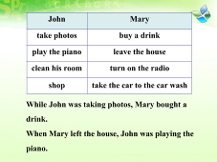
导入  时间  3 m | 2 | 引入本课话题，激活学生记忆。  教师提问：  Can you think of a time when you were late for class?  When was that?  What happened to you?  What did your teacher say to you?  Why do you remember the teacher’s words so clearly?
1a  时间  8 m | 3 | 讨论目标句式。  Think of another thing that you were late for or couldn’t go.  What was the event?  What was the reason why you were late or couldn’t go?  Please tell your partner about the story.  两人结对完成1a  找两、三对学生展示他们的讲述或对话。 | 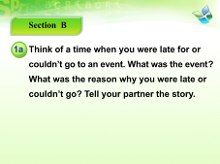
1b  时间  10 m | 4 | 读问题，预测听力内容。  Read the three sentences and guess the main idea of the listening test.  教师要求学生根据1b中的三个问题，预测一下听力内容，设一个听力目标：  What is the event?  根据问题3中的team won，至少可以预测到是有关game, match, competition, contest 之类的活动，再问：  What team game or sports can you name?  引导学生复习team和win等相关单词。
1b  时间  10 m | 5 | 看图预测听力内容。  Look at the picture and answer my question:  1．What is the girl in the picture doing?  2．Who is she calling?  3．What is she talking about?  4．Where is she now?  5．How is she? Is she happy or worried?  6．Why is she happy / worried?  学生看图，教师提问。 | 
1b  时间  10 m | 6 | 听录音，感知目标语。  播放第一遍录音，请同学回答听力目标问题，至少问三位同学，教师不给答案。
1b  时间  10 m | 7 | 听录音回答问题。  Listen and answer the three questions.  播放第二遍录音，学生完成1b，并核对答案。 | 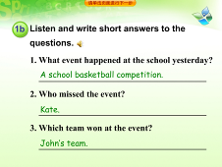
1c  时间  6 m | 8 | 听录音，完成排序。  Listen and number the sentences.  听第三遍录音，将句子排序。 | 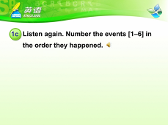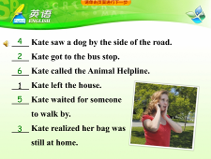
1d  时间  8 m | 9 | 进一步讲解目标语，加深学生理解。  After we finish the listening, do you understand the conversation?  教师通过问问题来询问学生对听力内容的理解。  1．What did she do when she got to the bus stop?  2．What did she do when she realized her bag was at home?  3．What did she see while she was running back home?  4．What did she want to do when she saw the hurt dog?  5．Why did she wait for someone when she wanted to call the  Animal Helpline?
1d  时间  8 m | 10 | 对话练习，进一步掌握目标语。  Work in pairs and make sentences together. One student begins a sentence with “when” or “while”, the other student finish the sentence.  出示例句让学生练习，之后找几组同学全班展示。 | 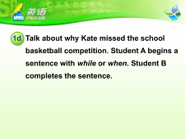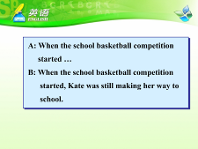
小结  时间  2 m | 11 | 总结本课所学目标语。  让学生按时间顺序复述听力内容。
拓展  时间  5 m | 12 | 拓展练习when和while的用法。  举例子，让学生根据今天发生的事情写句子。如：  When I walked into the classroom, all the students were reading new words.
作业  1 m | 13 | Homework(布置作业)  1．向一个同学讲述昨晚某一时刻你正在做的事情。  2．用when和while写5个句子。 | 